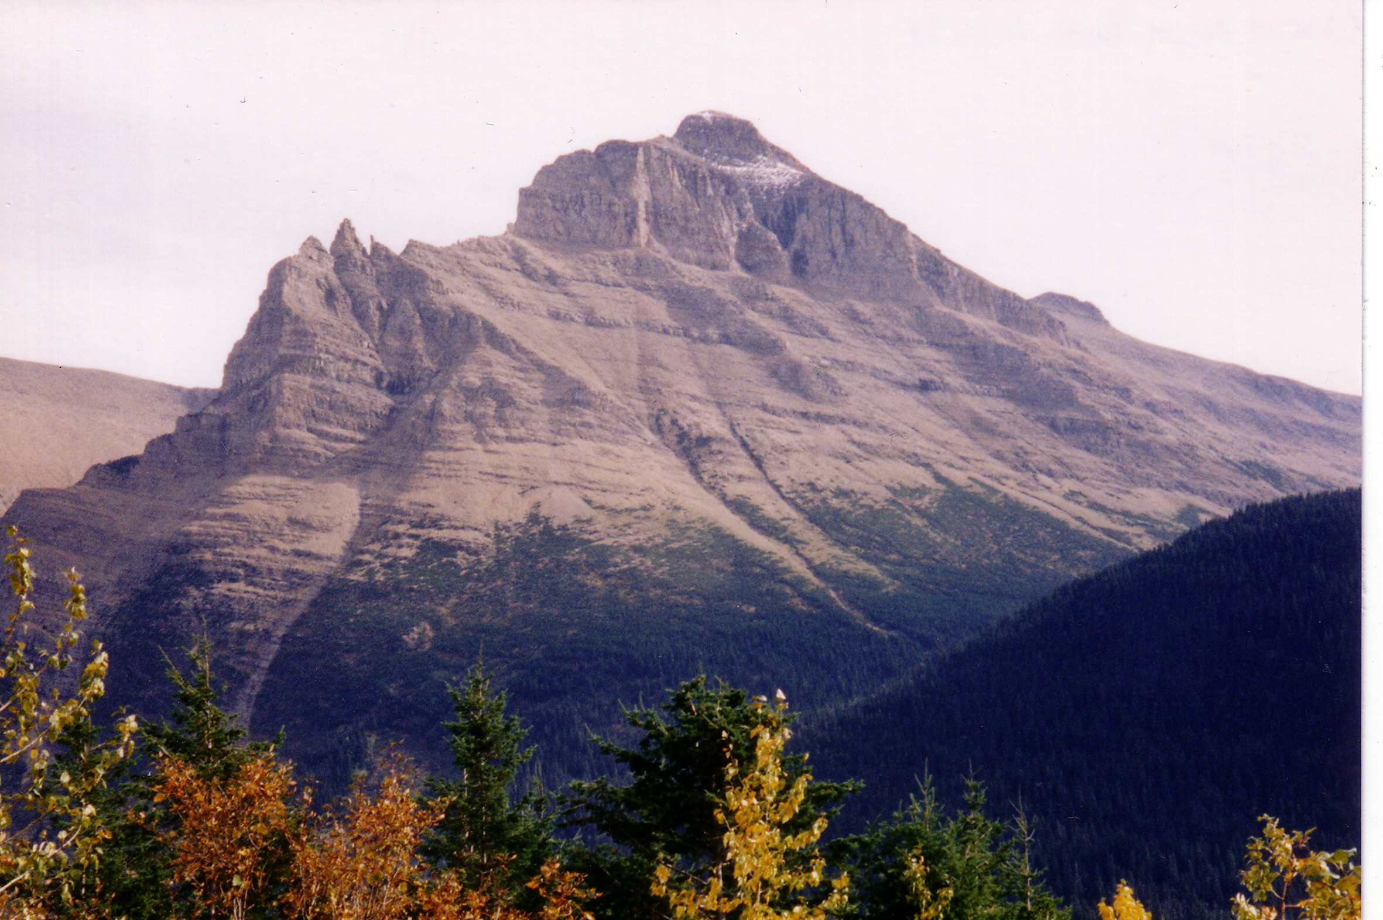
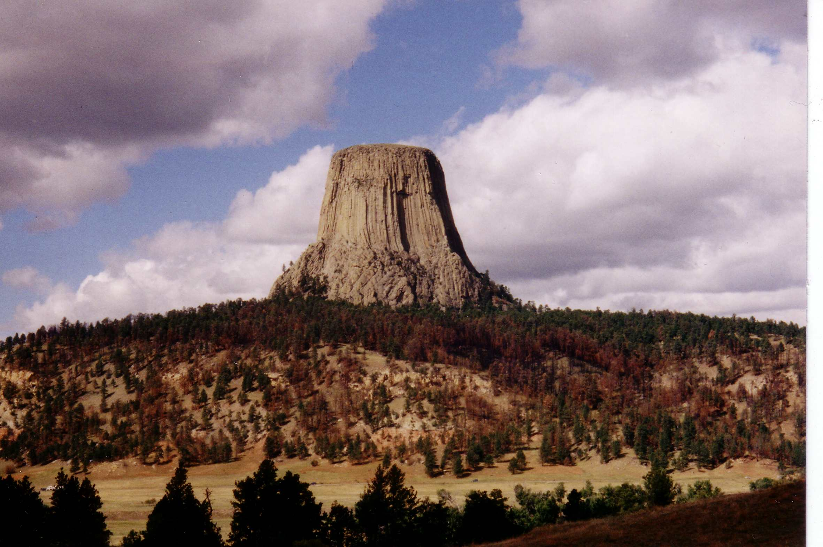
Mountains
Study Guide

Devils Tower, Wyoming Glacier National Park, Montana
Mountains
Directions: Use this Mountain website to help answer questions, define terms, fill in blanks, and take notes.
landform  terrain | 600  hills | rock  earth

A mountain is a ____________ that rises above the surrounding __________. In general, mountains need to be at least _______meters tall to be called a mountain. Otherwise, they are ________. Mountains are made from _______ and _______.

Define the following:
Summit -
Slope -
Gorge –

List the 5 types of mountains:
1.
2.
3.
4.
5.

Complete the table for each type of mountain. Write 2-4 facts, name an example, and insert an image for that example.

Fold Mountain:
Formation Notes (bullet list of 2-4 facts) | Example(s) (from Mountain site or ones you find) | Image of example (Image search and/or screen shot of Google Earth location)
- Formed when two plates collide together | - Rocky Mountains | 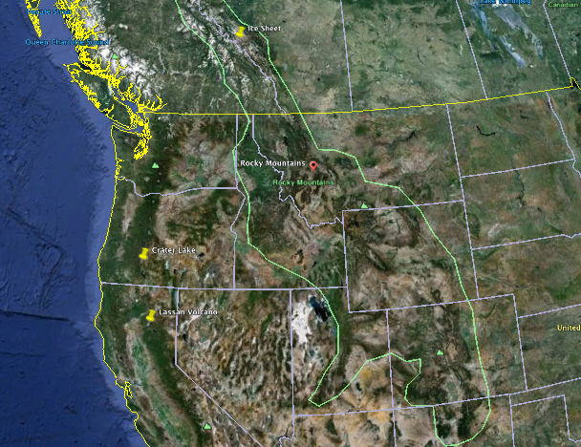

Fault Block Mountain:
Formation Notes (bullet list of 2-4 facts) | Examples(s) (from Mountain site or ones you find) | Image of example (Image search and/or screen shot of Google Earth location)
- Cracks force some crust up and some down | - Sierra Nevada Mountains

Plateau Mountain:
Formation Notes (bullet list of 2-4 facts) | Examples(s) (from Mountain site or ones you find) | Image of example (Image search and/or screen shot of Google Earth location)
- High flat land over 600m | - Canyonlands, Utah

